- PPPC Configuration for AnyDesk
Privacy Preferences Policy Control (PPPC) profiles are required to provide macOS privacy permissions to remote-support applications.
Configure the following permissions for AnyDesk, and any other applications found to require elevated privacy access, like OneDrive as required:
Permission | Purpose
Accessibility | Allows remote control of the Mac, including keyboard and mouse interaction
Screen Recording | Allows the remote-support application to view the user's screen
Full Disk Access | Allows access to protected files and system locations where required
Input Monitoring | Allows monitoring of keyboard/mouse input where required by the application
Note: The exact permissions required can vary depending on the application version and functionality being used.
Configuration using Intune Settings Catalog
- Go to Intune Admin Center → Devices → macOS → Configuration Profiles.
- Select Create Profile:
  - Platform: macOS
  - Profile type: Settings Catalog
- Search for Privacy Preferences Policy Control.
- Configure the following PPPC sections:
Accessibility
- Accessibility
- Add the application's Identifier.
- Configure the required authorization settings.
Use the current Authorization configuration where available rather than the deprecated Allowed setting.
Screen Capture
- Add the application's Identifier.
- Configure the required Authorization setting.
- This allows the remote-support application to capture/view the Mac's screen.
System Policy All Files
- Add the application's Identifier.
- Configure the required authorization.
- This is used for Full Disk Access / access to all files where required by the application.
- Add the required PPPC configuration for:
  - AnyDesk
  - TeamViewer Host
- Configure the required services:
  - Accessibility
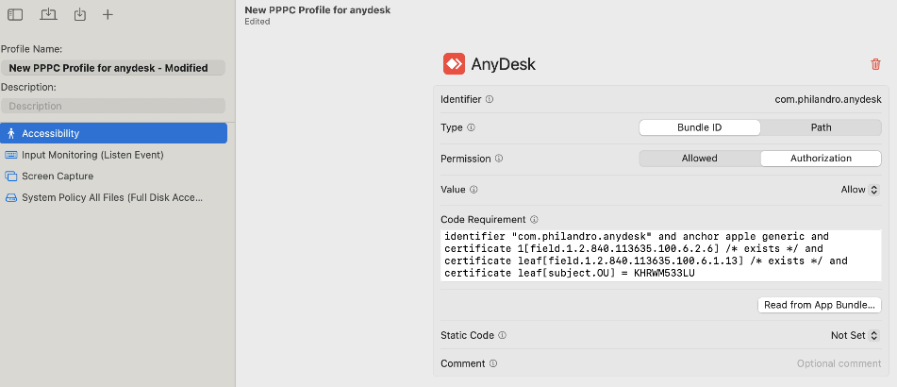
  - Screen Recording / Screen Capture
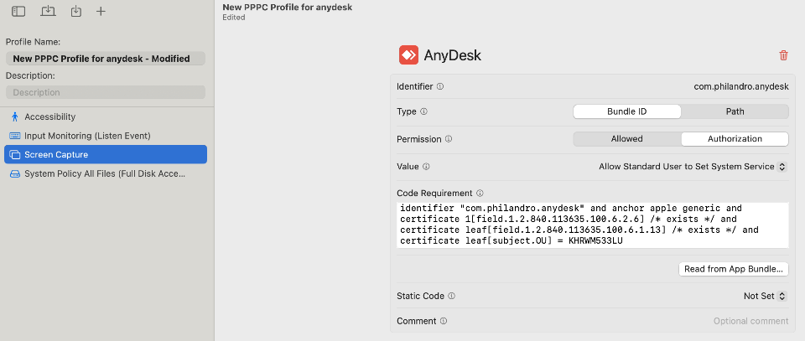
  - System Policy All Files (Full Disk Access)
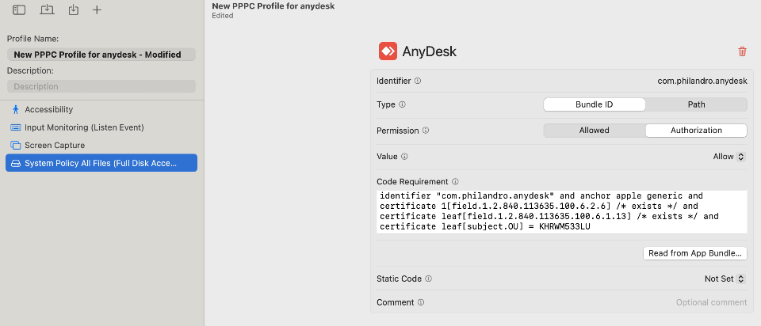
  - Input Monitoring
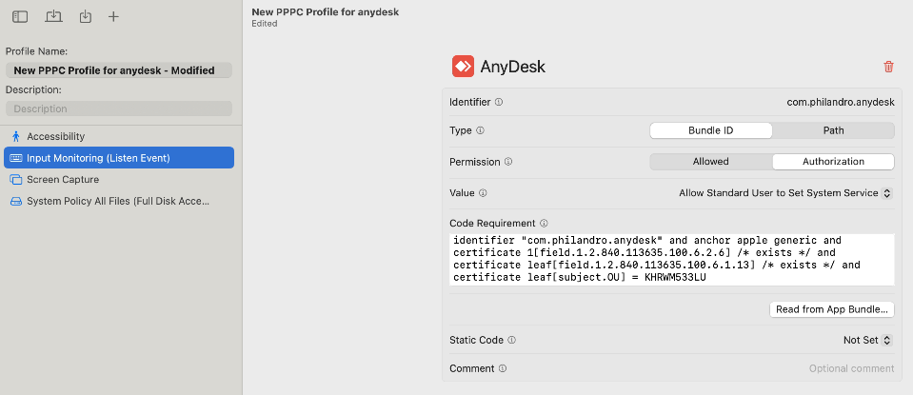
- Enter the application's:
  - Bundle Identifier
  - Code Requirement
  - Authorization
- Assign the profile to the required device group.
- Sync the Mac with Intune and verify the permissions.
2. Obtaining Bundle Identifier and Code Requirement
The Bundle Identifier and Code Requirement must match the application installed on the Mac.
Recommended: Intune PPPC Utility
Open the Intune PPPC Utility (no admin rights required) on a test Mac and use it to inspect the application.
https://github.com/gilburns/Intune-PPPC-Utility
The utility can:
- Identify the application's Bundle Identifier
- Obtain the application's Code Requirement
- Generate PPPC configuration entries
- Generate configuration suitable for Intune
This is the preferred method because it reduces the risk of manually entering an incorrect Code Requirement.
Alternative: Terminal
On the Mac, locate the application and run:
codesign -dr - "/Applications/AnyDesk.app"

The output will contain the designated requirement, for example:
designated => identifier "com.example.application" and anchor apple generic ...
The value after designated => is the Code Requirement used for the PPPC configuration.

To obtain the Bundle Identifier separately:
codesign -dv "/Applications/AnyDesk.app" 2>&1 | grep Identifier

Important: The Code Requirement should be obtained from the actual application version being deployed, rather than copied from an unrelated Mac or older application version.

Sources
- Privacy Preferences Policy Control device management payload settings for Apple devices - https://support.apple.com/en-sg/guide/deployment/dep38df53c2a/web
- How to Configure macOS Privacy Preferences Policy Control (PPPC) Using the Intune Settings Catalog - https://techcommunity.microsoft.com/blog/intunecustomersuccess/how-to-configure-macos-privacy-preferences-policy-control-pppc-using-the-intune-/4530406

- Local Administrator Password Solution (LAPS)
- Configure LAPS in the ADE Profile
- Go to Intune Admin Center → Devices → Enrollment → Apple → Enrollment program tokens.
- Select the relevant Apple Business Manager token.
- Open macOS → Enrollment profiles.
- Create a new profile or edit an existing ADE enrollment profile.
- Under Account Settings, configure the Local administrator account.
Configure:
- Local administrator account: Yes
- Admin account username: e.g. Admin
- Admin account full name: e.g. IT Administrator
- Hide in Users & Groups: Configure according to your requirements
- Admin account password rotation period: Configure the required rotation period
- View the LAPS Password
After the Mac has enrolled:
Intune Admin Center → Devices → macOS devices → Select device → Passwords and keys
Under Local administrator account password, authorized administrators can view the current LAPS password and the last rotation time.
- Manually Rotate the Password
To immediately rotate the password:
Intune Admin Center → Devices → macOS devices → Select device → Rotate local admin password
This can be used instead of waiting for the scheduled rotation.

- Custom Attributes for Device Inventory
https://intunestuff.com/2024/10/31/macos-intune-policies-guide-to-start/#Custom_Attributes

- Backing up the Configurations and Settings Locally
https://github.com/Micke-K/IntuneManagement

